How to Fix Error Code 0x800704cf? [Complete Guide]
Working as a part of a workgroup or a network makes many tasks easier since you are in constant attunement with every user connected to the same network.
For instance, you can divide work amongst all the members of the network; you can share files without manually going from person to person; updating a folder within the network will automatically update all the folders and files in computers connected to the same network; and many other similar operations can be managed spuriously.
Well, Windows 10 network and center functionality provides this opportunity to work as a whole setting up a network.
But as the convention talks around, with every uphill there comes a definite fall, Windows 10 follows the same role. Regardless of many such powerful tools and upgrades, it shows certain errors as well.
The error related to this network problem is commonly known as 0x800704cf. It basically interrupts your work when you try to access a computer network and comes along with an error message: “Network Error-Windows cannot access.”
What to do when you encounter error 0x800704cf?
The first thing to do when you confront this network error is to allow the Windows wizard to diagnose the cause of this error.
After scanning the entire system Windows will identify the root cause and will accordingly suggest you certain solutions. Just follow the on screen instructions to apply them.
But in case, these diagnostic repairs don’t work out, don’t despair. This is where the article here will guide you with several other relevant solutions.
Solution #1: Fix Error by Resetting TCP/IP
Shortly abbreviated for Transmission Control Protocol/ Internet Protocol, TCP/IP is an amalgamation of communication protocols which helps devices interconnect with internet. Now if this error is occurring repeatedly, there is a chance there is something wrong with your TCP/IP.
So resetting the protocols would most probably ride out the error:
Step 1. Firstly, right click on the “Start” icon and choose “cmd (Admin)” from the context menu.
Step 2. As soon as the black dialogue box appears, enter the following command “ipconfig/flushdns” to clear your DNS (Domain Name Server) cache data.
Step 3. Now within the same operating box, enter the command “nbtstat-RR”. This will refresh the NetBIOS entries.
Step 4. Type next “netsh int ip reset” command. This will reset the IP settings.
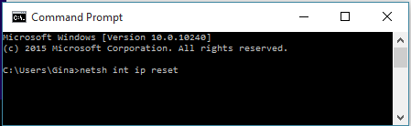
Step 5. Now the last command to be entered in the cmd is “netsh winsock reset”.
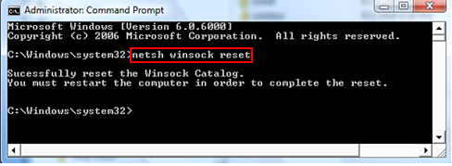
Eventually exit the command prompt and reboot your computer to give it a fresh start.
The trouble is most likely to go away.
Wait, it is still there? No worries. There are still plenty of more solutions waiting ahead.
Solution #2: Modify Adapter Settings
This is the most basic and quickest attempt to sort out the issue, changing the adapter settings. There are times when unexpectedly certain changes happen within the system without your knowing. And this is one of them.
Let’s not waste too much time apprehending the causes, rather focus on the solution part more. For that read the steps aligned below:
Step 1. Press “Windows logo + I” keys together to bring out the “System settings” Window.
Step 2. Here go to the “Network & Internet (WI-fi, Airplane mode, VPN).
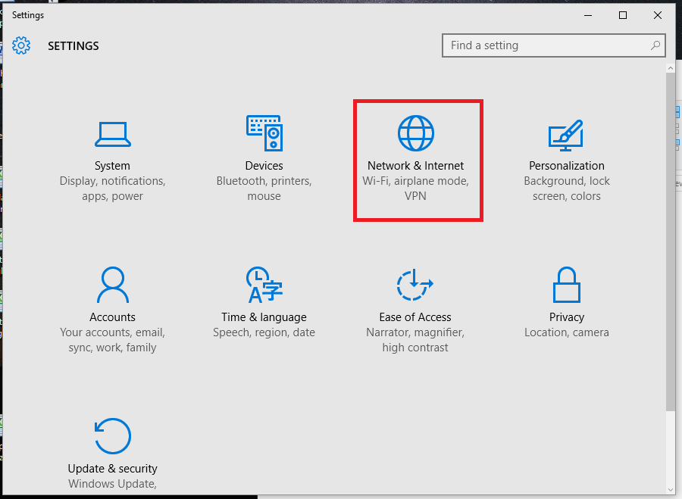
Step 3. The network connections which are currently available will be shown on the screen now.
Step 4. So scroll down the page to look for “Change Adapter” settings option. Click on it to get the access inside.
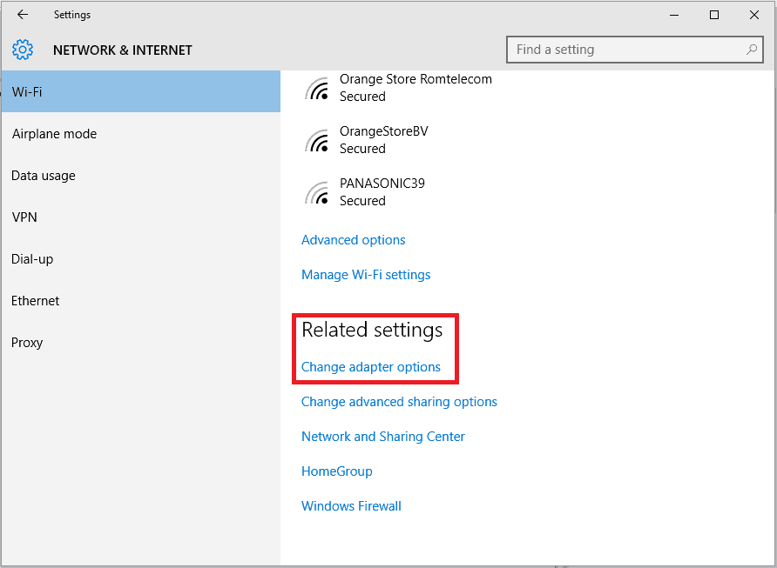
Step 5. Now from the network connections displayed on screen, right click on your particular Wi-fi network and choose “Properties” from the context menu.
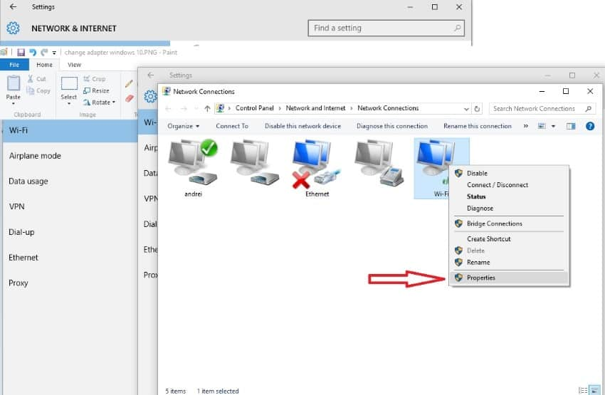
Step 6. Next simple uncheck the checkbox of “client form Microsoft Networks”. Save the changes you just made and restart your computer.
So this one solution may root out the issue. But if it is still persisting, don’t lost hope. We still have got few tricks in our store.
Solution #3: Reinstall Network Adapters
If the problem is still recurring, then you should make an attempt to reinstall the network adapters to diagnose and apply any hardware changes if required.
Here is how you do it:
Step 1. In the Windows search box, type “Device Manager” and choose the first result with a click on it.
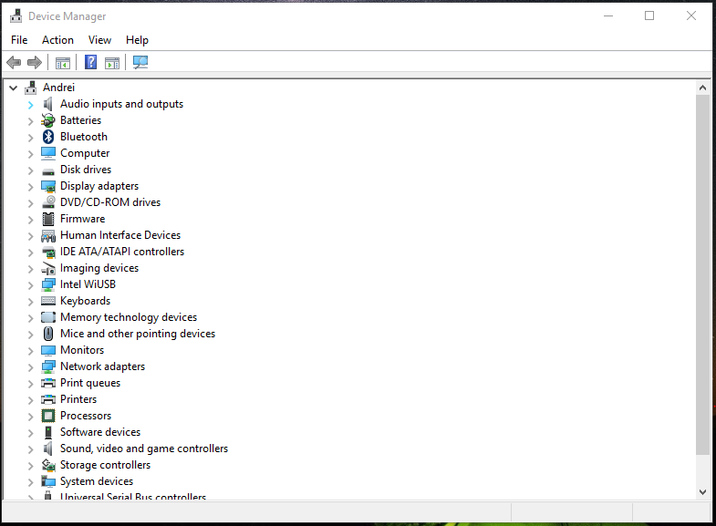
Step 2. Off the menu bar, click on “View” and then choose “Show hidden devices” from the drop down menu.
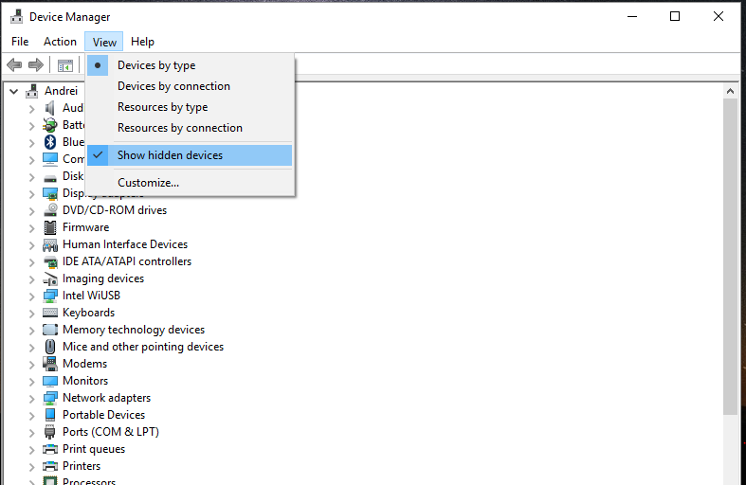
Step 3. Now go to the “Network Adapters” and click on it to expand it.
Step 4. Uninstall the list of network adapters one by one by choosing “uninstall” option from the right click context menu. If you are unable to uninstall any particular network adapter, don’t worry. Just go to the next adaptor option.
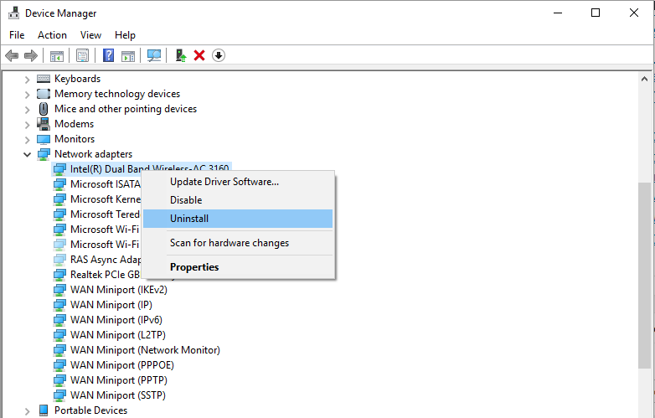
Step 5. Once you are done with this, go to the “Action” option in the main panel and click on “Scan for hardware changes”.
Step 6. Finally save your changes, and restart your computer.
Conclusion:
Error code 0x800704cf mostly appears when you connect yourself frequently with too many anonymous networks. Try to refrain using too many network adaptations.
The methods aforementioned will definitely help you sort it out. But if you are still in doubt, don’t try anything more. Just seek an expert advice to avoid any further damage to the system.
Keep visiting the site for more Windows and Mac information.

